Journal #18: William Hogarth’s Marriage A-la-Mode Body of Work (BOW)
Identify appropriate global issue that is also seen within Pygmalion.
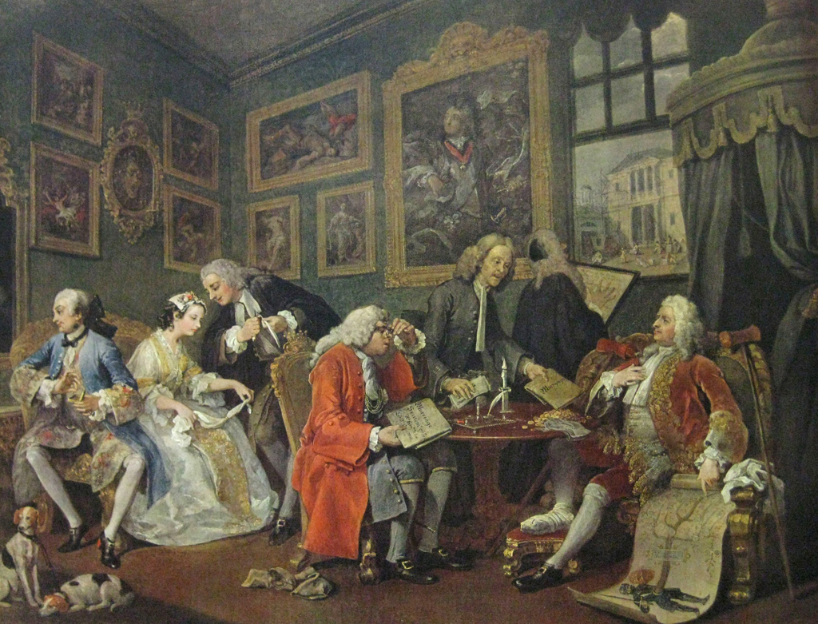
Annotate image for at least 1 big 5 that helped exemplified the global issue asserted.
The Marriage Settlement (the name on its frame), called The Marriage Contract by W. Hogarth

