To Kill a Mockingbird Chapter 23 Name: ________________
- Even though Scout idealistically believes all folks are simply folks, Jem has grown realistic about the rigid social structure of his town, which may be as detrimental as India’s caste system. Why don’t you read carefully what Jem and Scout discuss about the social structure of the Maycomb of 1933 and draw a pyramid of social hierarchy in Maycomb?
- Place the Finches, the Cunninghams, the Ewells, and blacks in the appropriate section.
- Try to create a label for each social class to which the Finches, the Cunninghams, the Ewells, and blacks belong.
The Caste System in India | Jem’s view of the Maycomb of 1935
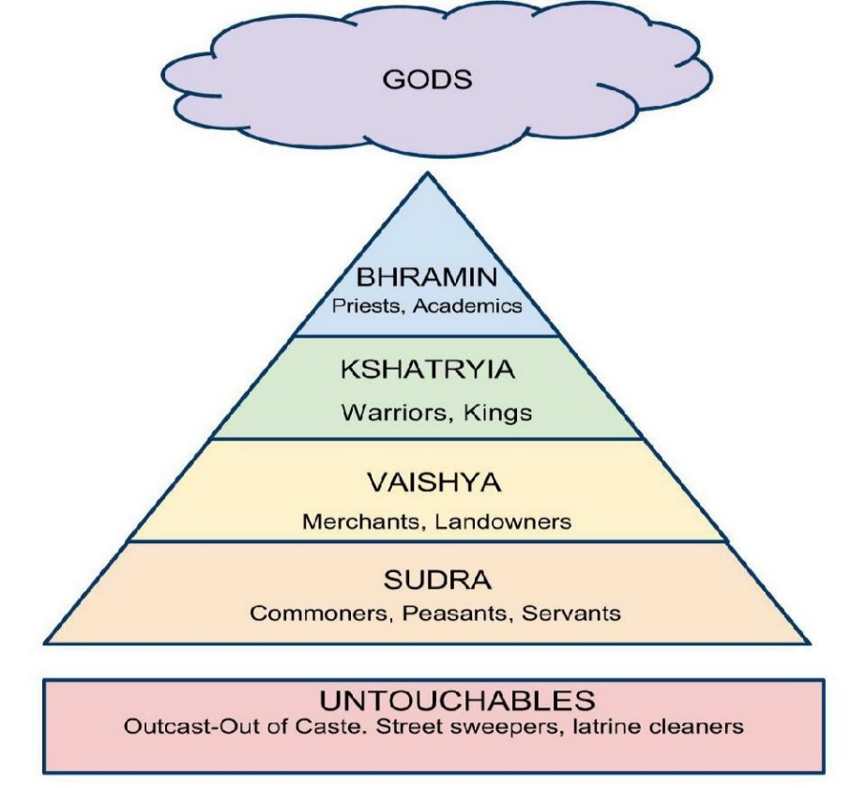
Food for thought:
- In such a society, do you think wrongs done to socially-disenfranchised people can be rectified?
- If you were born in such a culture, what line of action would you take? Would you conform to, or challenge, the social norms?
Name: _________________
How did Maycomb grow inward?

Class | Landed gentry | Blue-collar Workers  (land-poor farmers) | Social Dependents | The Powerless
Families | The Finches | The Cunninghams | The Ewells | Blacks
Social distinction | Integrity, compassion  Moral authority | Pride and self-reliance | Nothing but racial pride | Individual character and self-control
Aunt  Alexandra’s diction | “gentle breeding” | “run-of-the-mill people” “trash”  “Tacky” and “yappy” | (“untouchables”?) | (“darky”  “untouchables”?)
Symbols | Snow-on-the-mountain camellia (as in Mrs. Dubose’s case) | Cotton/ KKK/ hood | Garbage dump with  geranium pots | Living near the garbage dump with delicious smells
Exceptions | Dolphus Raymond | KKK some may learn to be rational and sensible | Mayella Ewell, hemmed in by race and economy | Calpurnia  Tom Robinson and others
How do they live? | The Finches are very respectable because of their legacy and personal conduct. Descendants of slave owners, the Finches still have their country estate, Finch’s Landing, and means to educate their children and to maintain social standing.

