Logos, Ethos, Pathos
Some twenty-five hundred years ago, a Greek philosopher and rhetorician Aristotle identified three key elements writers can use to convince and persuade their audience: logos, ethos, and pathos.

 | Logos | Ethos | Pathos
Definition | Appeals based on facts and reason | Appeals based on character | Appeals from the heart
Greek Etymology | embodied thought | Character | Suffering or experience
Structural content | Claim + supporting evidence | Claim + supporting credential | Claim + supporting emotion
Booster tools | Reason  Clear, rational ideas  Specific details  Facts  Statistics | Writer’s authority  Writer’s credential | Audience’s values  Desires  Hopes  Humor  Fears  Prejudices
Dangers | Even numbers can lie. | Character assassination  Celebrity endorsement  Image politics | Demogogues can rise to power using propaganda.  Cult of personality

Spot it, call it out

Emotional Fallacies, or How Some Manipulate Reader’s Emotion
Scare tactics | Creates fear in people as evidence to support a claim. Mostly this is done by some form of threat.  Think about communist propaganda.
Either-or choices | False dilemma  “You are either with us or against us.”  “Either a ballbreaker or a scam artist will be America’s 45th president.” ( how about Sanders?)
Bandwagon appeal | A bandwagon argument creates the impression that everybody is doing it and so should you
Slippery slope | This argument activates fear in the audience by claiming today’s tiny misstep will turn into the slide into disaster in the future.
Overly sentimental appeal | By singling out and exaggerating a particularly heart-wrenching situation or individual case, some writers use emotion as a driving force and make the reader feel guilty if he or she does not support the argument.

Ethical Fallacies, Or How the Author Misrepresents His or Her Credential
Appeal to false authority | A fallacy in which someone who has no expertise on the topic is cited as an authority
Dogmatism | 1. the expression of an opinion or belief as if it were a fact  2. a stubborn viewpoint or system of ideas based on insufficiently examined premises  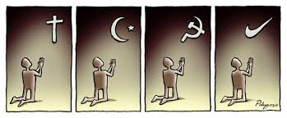
Ad Hominem argument | “Against the man” to discredit his message  Person A: I think that the U. S. will come out of this recession quickly.  Person B: What do you know about economics? You don't even have a job!  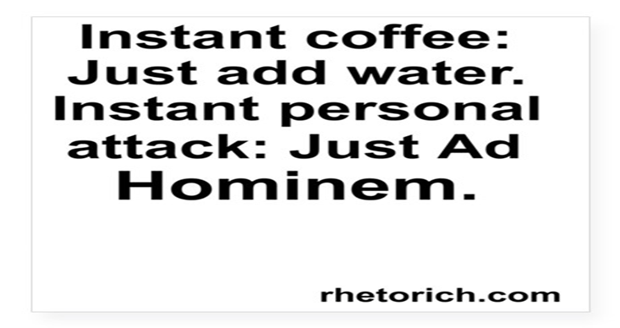
Stacking the deck | Some writers choose to show only one side of the story that they favor.  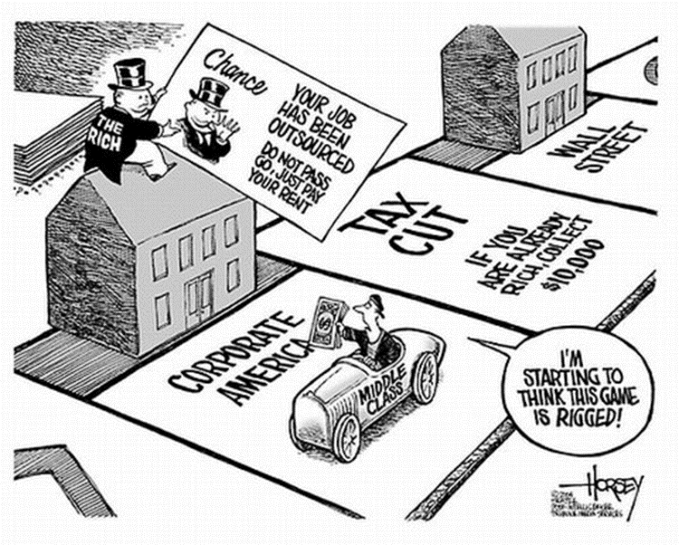

Logical Fallacies, Or How the Author Distorts Reality and Facts
Hasty generalization | Draws a conclusion about a population based on a small sample (jumping to conclusions).  Stereotyping
Faulty causality | Post hoc, ergo propter hoc = after this, therefore because of this  Using causal connection between unrelated events, some writers try to take the credit for an undeserved success or blame others for a disaster.  “Katrina was the reason why New Orleans was flooded.”  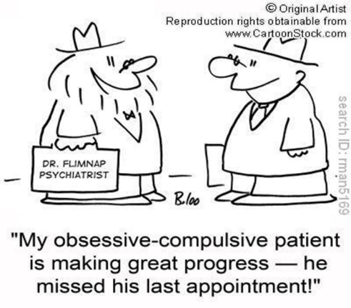
Begging the question | 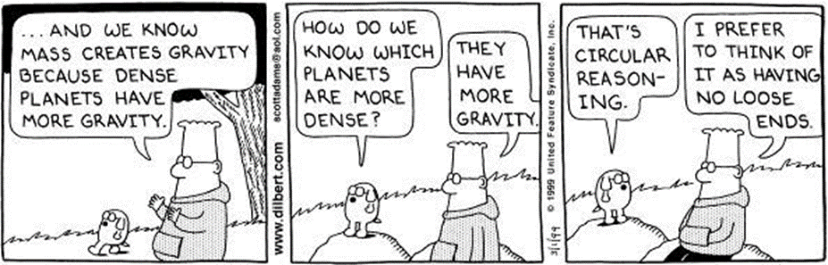  Aka Circular reasoning  - The Bible affirms that it is inerrant.  - God inspired the authors of the Bible.  - Therefore, the Bible is inerrant.  The verity of Claim 1relies not on its evidence but on another claim (2). And thus, there is no way to prove either Claim 1 or Claim 2 to be correct, This kind of fallacy repeats itself as if running the loop.  Another Example:  A: Your resume looks impressive but I need a reference.  B: C can give me a good reference.  A: Good. But how do I know that C is trustworthy?  B: Certainly. I can vouch for C.  B is qualified for the job (Claim 1) since C guarantees B’s qualification (its evidence). C is qualified as a reference (another claim) since B vouches for C’s qualification (its evidence).  Some more fallacious arguments based on circular reasoning:  “Why is America the best country in the world?”  "God exists because the Bible says and the Bible is the infallible word of God."  “You cannot give a B. You will hurt my chance to get into the medical school if you give me a B.”
Equivocation | the misleading use of a term with more than one meaning or sense  FIRST WITCH  When shall we three meet again?  In thunder, lightning, or in rain?  SECOND WITCH  When the hurly-burly’s done,  When the battle’s lost and won.  Fair is foul, and foul is fair  Hover through the fog and filthy air.  FIRST WITCH  Lesser than Macbeth and greater.  SECOND WITCH  Not so happy, yet much happier.  THIRD WITCH  Thou shalt get kings, though thou be none.  So all hail, Macbeth and Banquo!
Non sequitur  (“It does not follow” in Latin) | an argument in which its conclusion does not follow from its premises  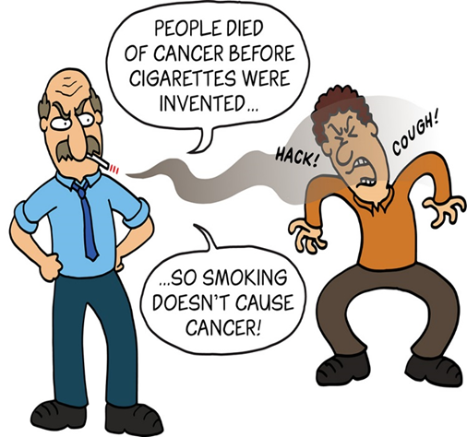
Straw man | A fallacious argument that uses an out-of-context quotation from the opponent’s argument  Or that presents a poor representative as the defender of the opposing argument  Or that creates a fictitious persona with an unreasonable opinion only to refute it
Red herring | an irrelevant topic introduced to divert the attention of listeners from the original issue  a common device used in mystery and thriller stories to distract the reader from identifying the real culprit or in politics to dodge difficult problems  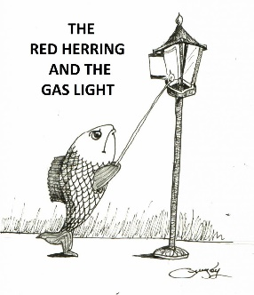
Faulty analogy | An inaccurate, unreasonable comparison between two things that do not share common criteria  Is Beauty and the Beast just like Romeo and Juliet?

