Understanding Satire
Seed Question:
Area of Exploration: Readers, writers & text: In what ways is meaning constructed, negotiated, expressed and interpreted?

What is Satire?

Satire—in its literary, graphic art, or performance form—uses humor, wit, parody, hyperbole, pun, irony or burlesque to mock and ridicule its target in an attempt to redress or improve the perceived ill or problem.

It is a technique employed by writers to expose and criticize foolishness and corruption of an individual or a society; in a satire, a writer uses fictional characters, which stand for real people, to expose and condemn corruption.

What is the purpose of satire?

Although satire is usually meant to be humorous, its greater purpose is often constructive social criticism, using wit to draw attention to both particular and wider issues in society. Satire and irony in some cases have been regarded as the most effective source to understand a society and human nature. For example, the ancient Greek philosopher Plato referred his friend who was seeking to understand Athenian society, to the plays of Aristophanes, the celebrated “Father of the Comedy.”

Ultimately, a satire is a comical piece of writing which makes fun of an individual or a society, to expose its stupidity and shortcoming.

Why do you think some choose to write satire?

Satire's job is to expose problems and contradictions, and thus even when it fails to bring about solution or changes, satire nonetheless grants its readers a sort of comedic license to mock prominent individuals and powerful authority. Not unlike a pressure release valve, satire can carry out the function of reducing—if not resolving—social tension. For example, Shakespearean Fools testify to this tradition of allowing court jesters to speak truth to power however unpleasant it may be. This safety valve, or comic relief, helps restore balance and provide a collective sense of harmony.

In other words, the role of satire is to ridicule or criticize those vices in society the writer considers to be a threat to civilization. The writer considers it his obligation to expose these vices for the betterment of humanity. Therefore, the function of satire is not to make others laugh at persons or ideas they make fun of. It intends to warn the public, and to change people’s opinions about the prevailing corruption and conditions in society.

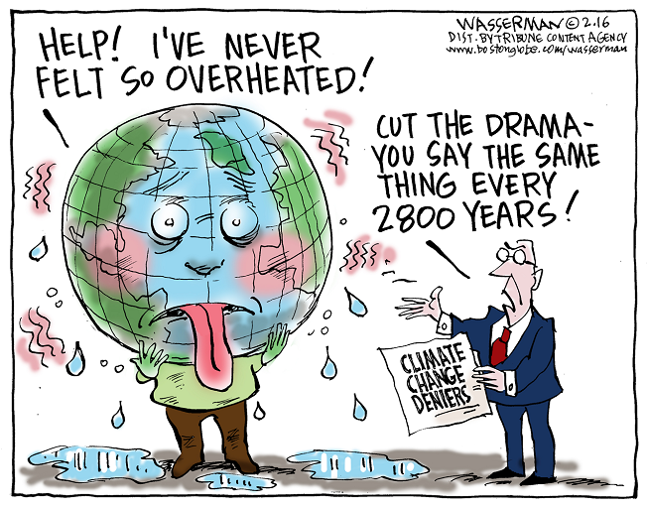
What are the tools of satire?

Horatian satire:
indulgent, tolerant, amused, and witty, wry in the tradition of the Roman satirist Horace; rather than attacking evils, Horatian satire ridicules universal human folly so that the reader might identify with what is being critiqued and laugh at him/herself as well as at society.

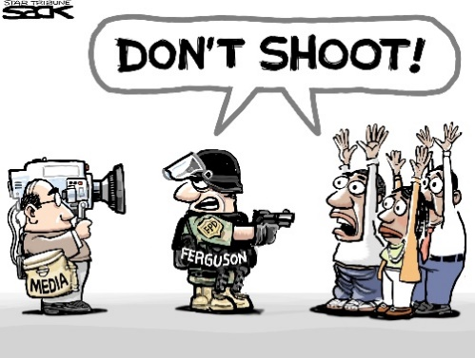
Juvenalian satire:
Harsh and realistic attack against vice or error with contempt and indignation in the tradition of the Roman satirist Juvenal; Juvenalian satire thus is more contemptuous and abrasive, and uses strong irony and sarcasm. Polarized political satire is often of this nature, and aims to provoke change. Juvenalian satire is not often as humorous.

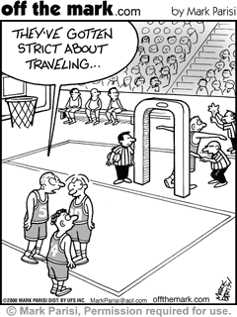

Burlesque: a form of comedy characterized by ridiculous exaggeration and distortion between subject matter and style. That is, a style ordinarily dignified may be used for nonsensical matter, or a style very nonsensical may be used to ridicule a weighty subject. i.e. the subject contains frivolities, that are treated seriously, and the serious elements are treated frivolously-everything (generally) is an opposite.

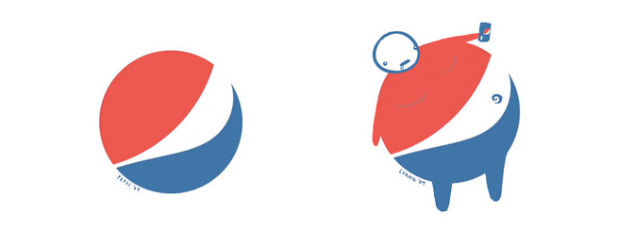
Parody: a composition that imitates the serious manner and characteristic features of a particular work, or the distinctive style of its maker, and applies the imitation to a lowly or comically inappropriate subject.

Irony: verbal, situational, dramatic irony
Verbal irony- occurs when a speaker or narrator says one thing while meaning the opposite. Its purpose is usually to criticize. EX: In Shakespeare’s The Tragedy of Julius Caesar, Antony repeats several times that “Brutus is an honorable man,” when he means the exact opposite
Situational irony- occurs when a situation turns out differently from what one would normally expect- though often the “twist” is oddly appropriate. EX: A deep-sea diver drowning in his own bathtub
Dramatic irony- occurs when a character says or does something that has more or different meanings from what he/she thinks it means, though the audience and/or other characters do understand the full ramifications of the speech or action. EX: In Shakespeare’s The Tragedy of Romeo and Juliet, Romeo kills himself because he believes Juliet is already dead; which some of the characters and the audience know is untrue.

Pygmalion Thematic Analysis Assignment: Project 1

Throughout Pygmalion, various satire techniques are used to develop GBS’s social commentary on the difference between classes. George Bernard Shaw utilizes satire in the play in order to ridicule the rigidity and hierarchy of British society that existed in the late nineteenth and early twentieth century, and he is able to portray this by using the character of Eliza Doolittle, who is initially a poor girl that lives on the streets. In addition, GBS also lampoons the stereotypical expectations of gender roles and power dynamics between the sexes.
To sum, the whole play is a satire, and in order to emphasize the flaws in social classes, Shaw takes a disenfranchised citizen of British society, Eliza Doolittle, and uses her as a mouth-piece for his message.
Throughout the play, what is George Bernard Shaw’s message? What is he satirizing or criticizing? Find at least 3 quotes that help highlight Shaw’s message.

Hint: Think about the following among others:
Society and Class
The Power & Purpose of Language
Gender Roles: Attack on the sexual stereotypes
Middle Class morality & Victorian Prudery
Identity/transformation
Education & Intelligence

Once you have identified the satire Shaw was trying to emphasize, you will create a satirical visual that expands on criticism identified. Keep in mind once you are done with your visual, you will be writing an essay emphasizing your choices and message. That is, there are four projects in total: Project 1 (thematic analysis), Project 2 (visual text), Project 3 (written text), and Project 4 (a comparison essay).

Quote w/citation:  - Conventional attitude  - Satirical take  - Satirical take | What global theme does it tackle?  Focus on one common theme. | Message trying to deliver:  What does GBS mock, attack, or expose?

